**Instructions- Wamp Server, phpMyAdmin, WordPress**

(**Wamp** **install video**: https://www.youtube.com/watch?v=yj_KWo4pNzE)

1] Download Wamp server - <http://www.wampserver.com/en/>

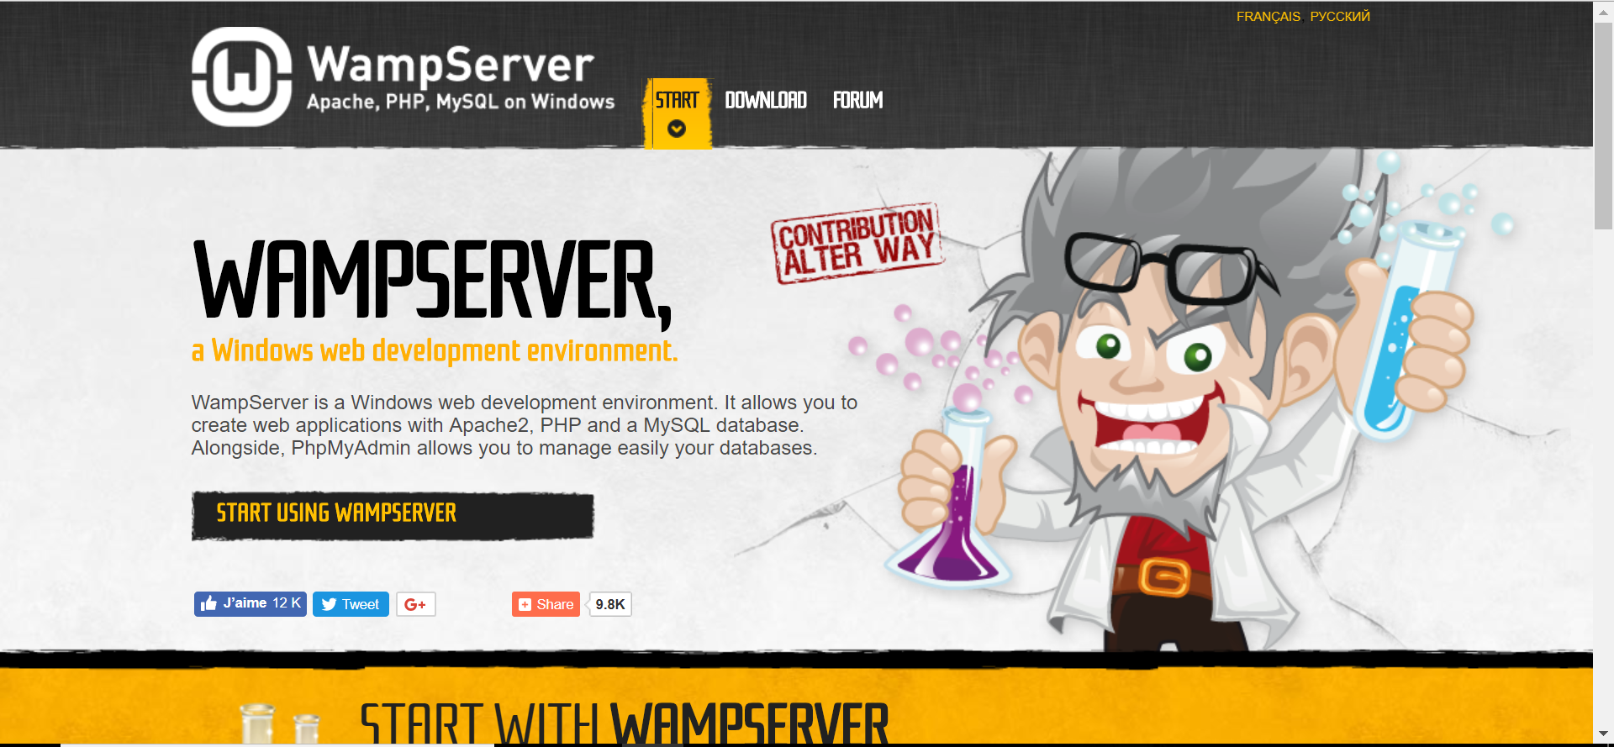

Go to download

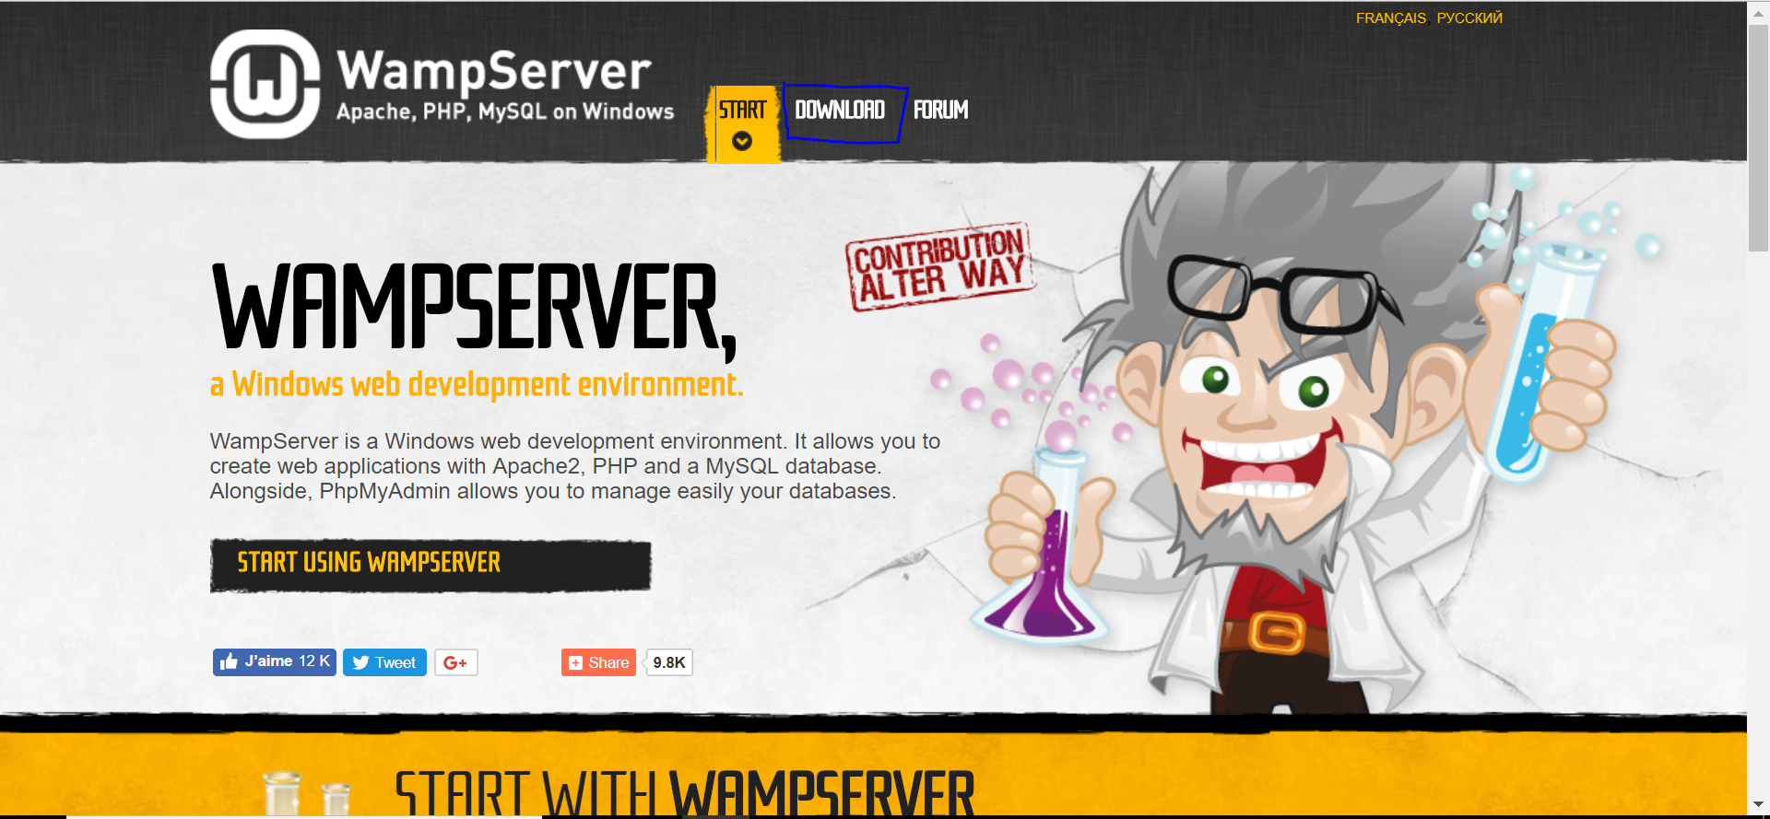

Scroll down the page on download

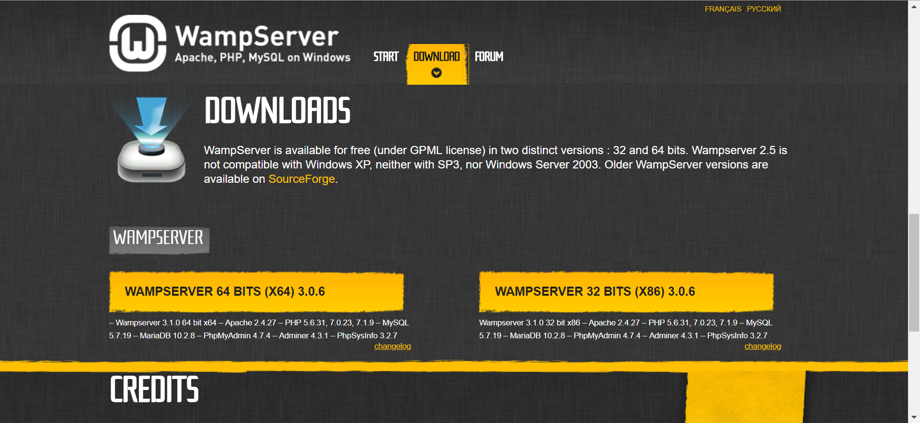

Click on WAMPSERVER 64 BITS (X64) 3.0.6 or WAMPSERVER 32 BITS (X86) 3.0.6

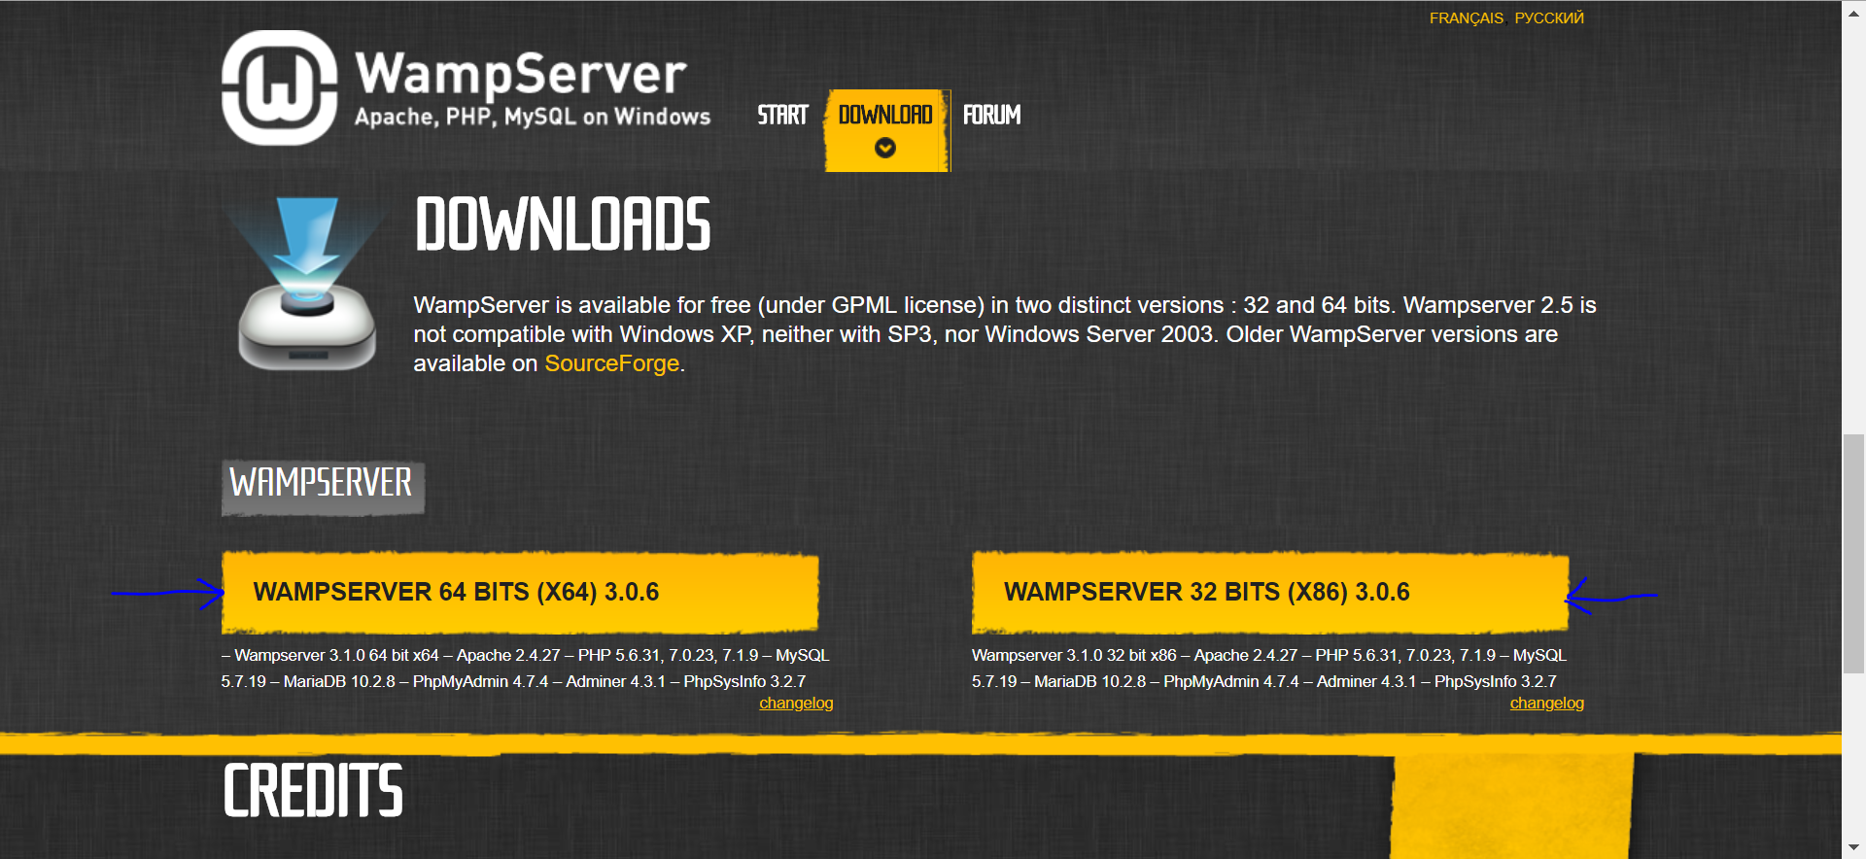

Click on link provided for visual studio 2012

**Ctrl + enter**

**For direct link:** https://www.microsoft.com/en-us/download/details.aspx?id=30679

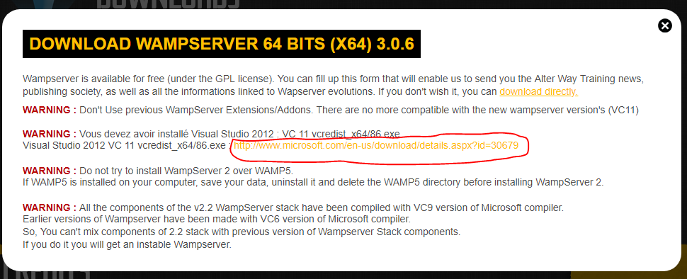

Click on download directly

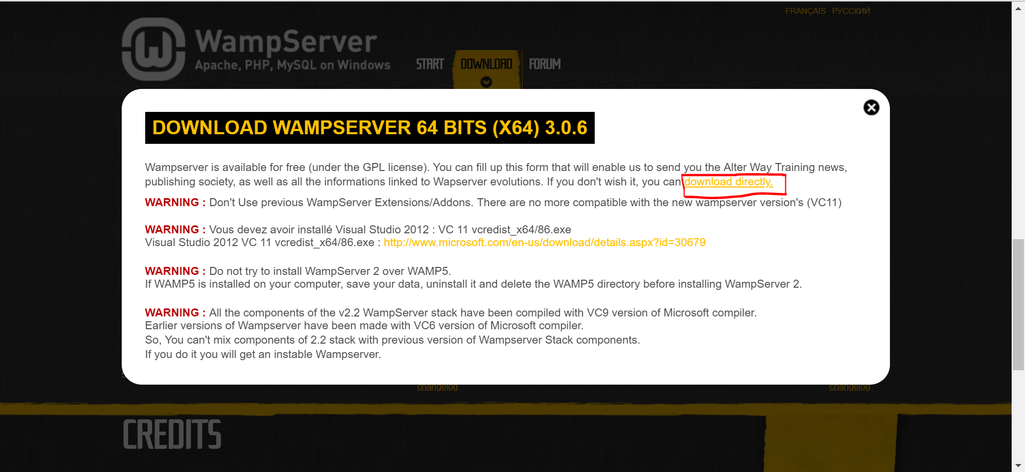

Click on WampServer 3 folder

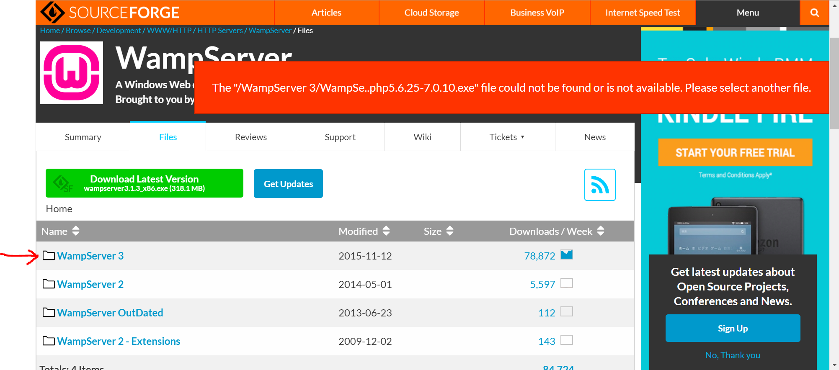

Click on WampServer 3.0.0 folder

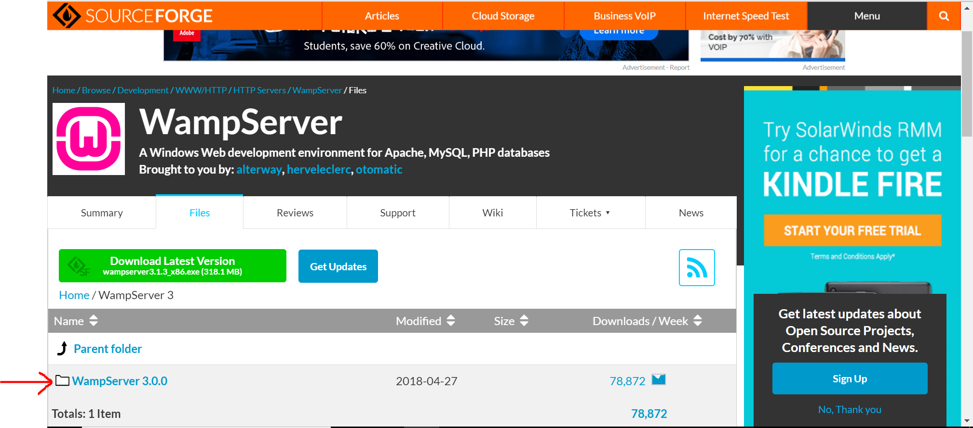

Choose your appropriate option based on your operating system

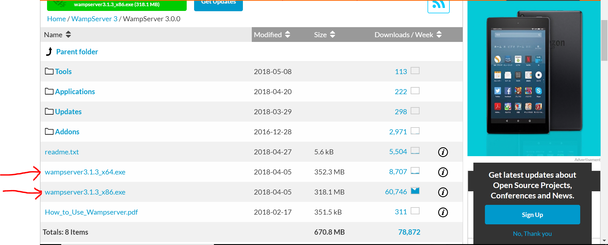

Wamp server will be downloaded and you will receive the Wamp server exe file. Run that file as administrator (right click – run as administrator)

After installing, you should have the Wamp folder in your C drive.

Before you continue, stop all Wamp Services by right clicking on the Wamp service in the taskbar. Right click – stop all service.

After you stop service, copy the WordPress folder that we provided.

Go to your drive C – Wamp64 (Wamp folder) – www – paste the WordPress folder here.

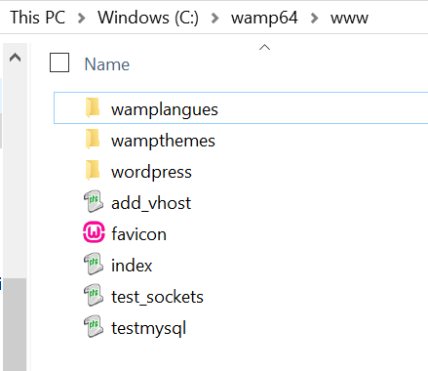

Next, start the Wamp server by double clicking on Wamp server or app that on your desktop.

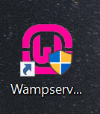

Once it’s started, you will have a green light on Wamp icon that is on your taskbar.



**Note : if the Wamp server symbol doesn’t turn into green that means that your Wamp server is not running.**

**2] Import database in phpMyAdmin**

Go to your browser,

Type localhost on your URL, you will see the screen below.

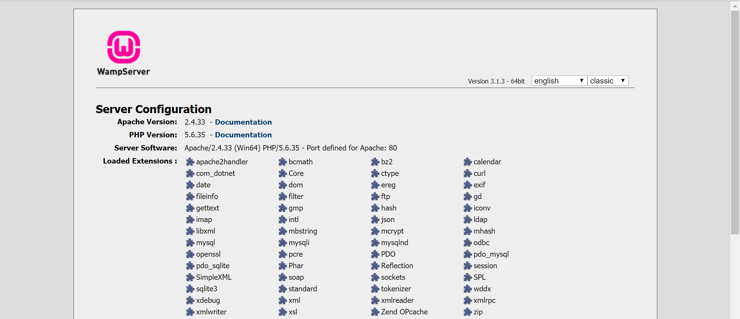

Scroll down the page, you should see a phpMyAdmin folder.

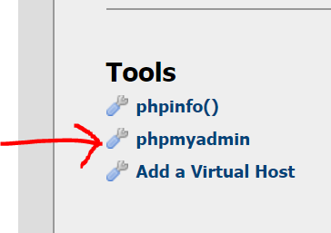

Click on phpMyAdmin and you will see the screen below.

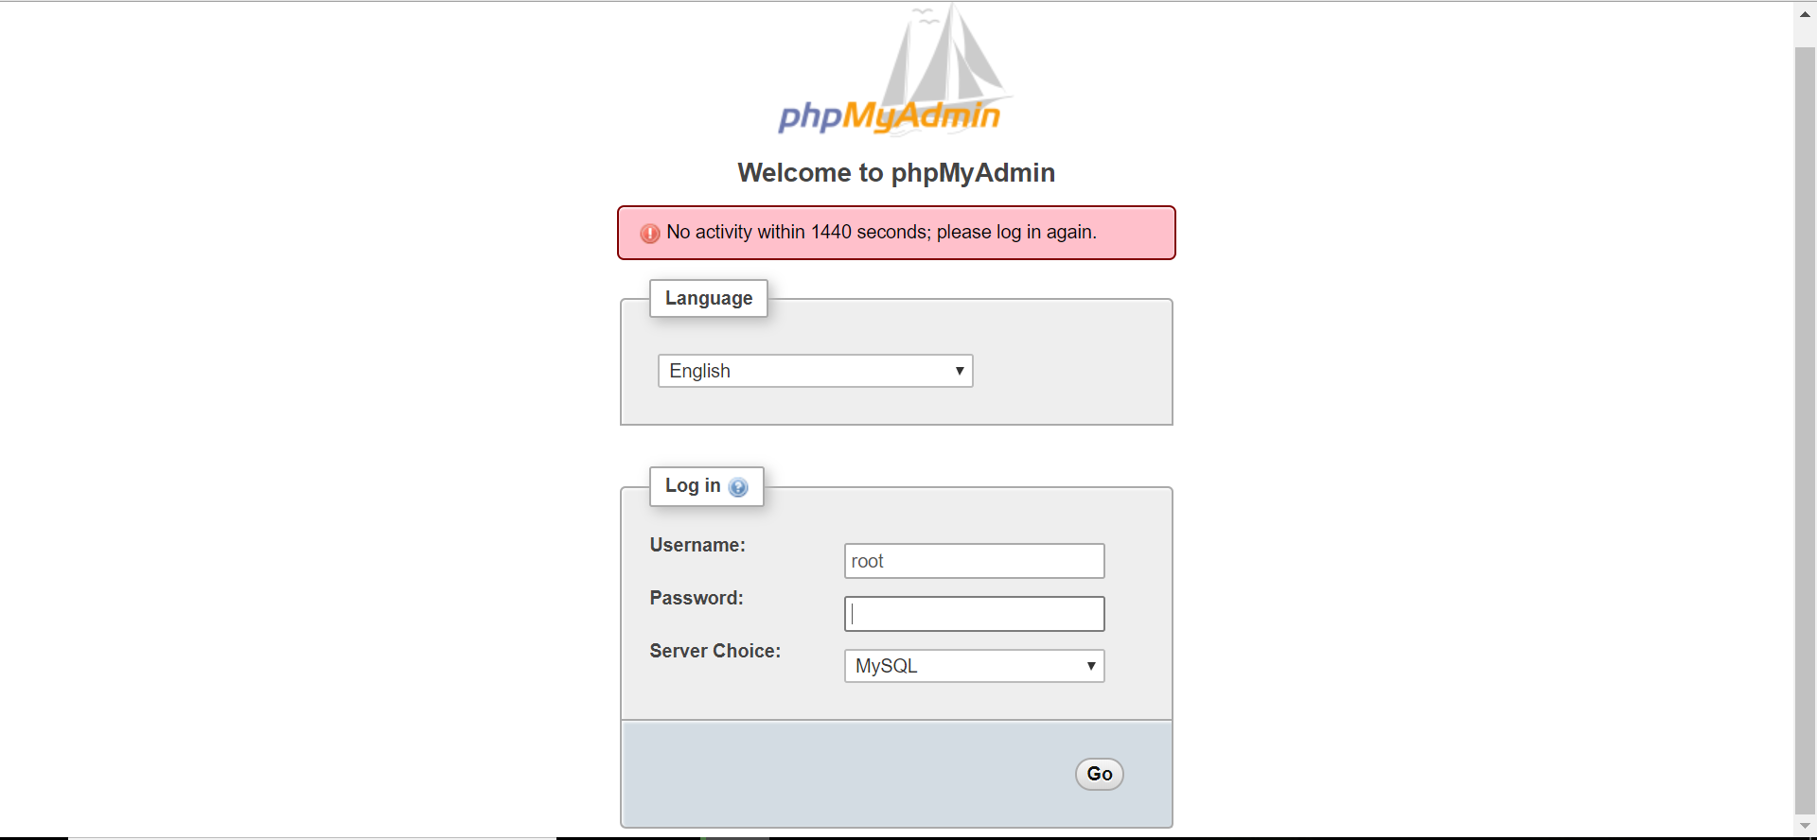

Click on the “Go” button. ‘Username: root’ and ‘Password: leave this field blank’

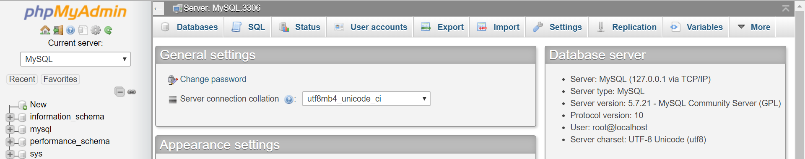

Next, import the database.

You have 127_0_0_1.sql folder for database. Click on the import tab in phpMyAdmin.

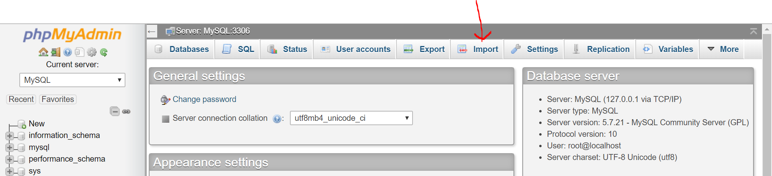

You will see the screen below.

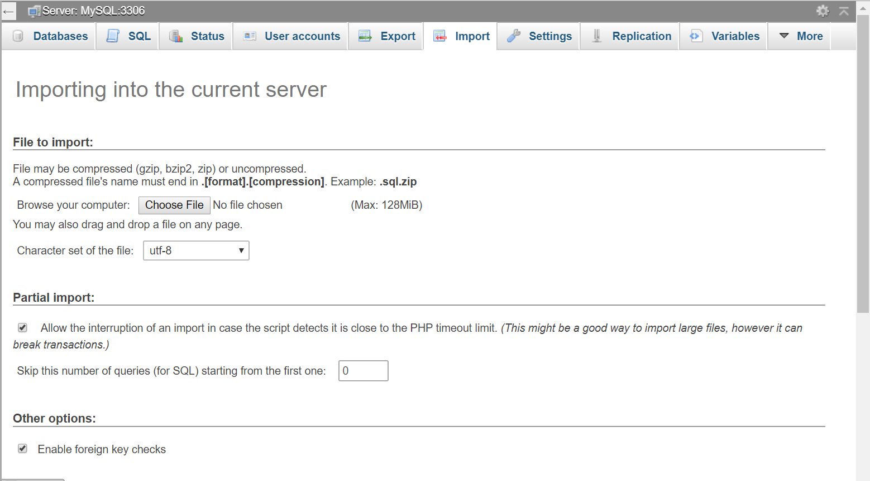

Click on choose file option. Choose file as 127_0_0_1.sql folder – scroll down page – click on the “Go” button

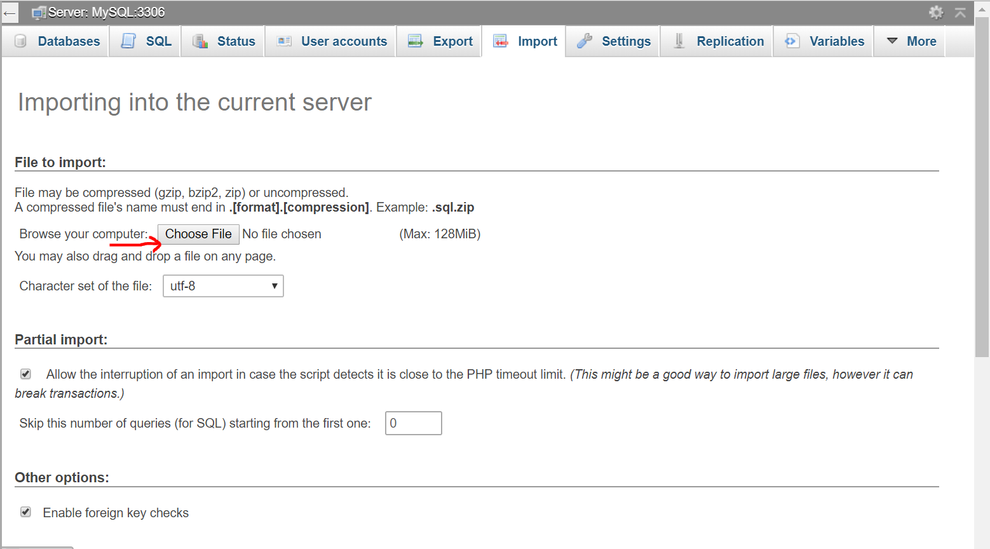

Now your database will be imported into phpMyAdmin.

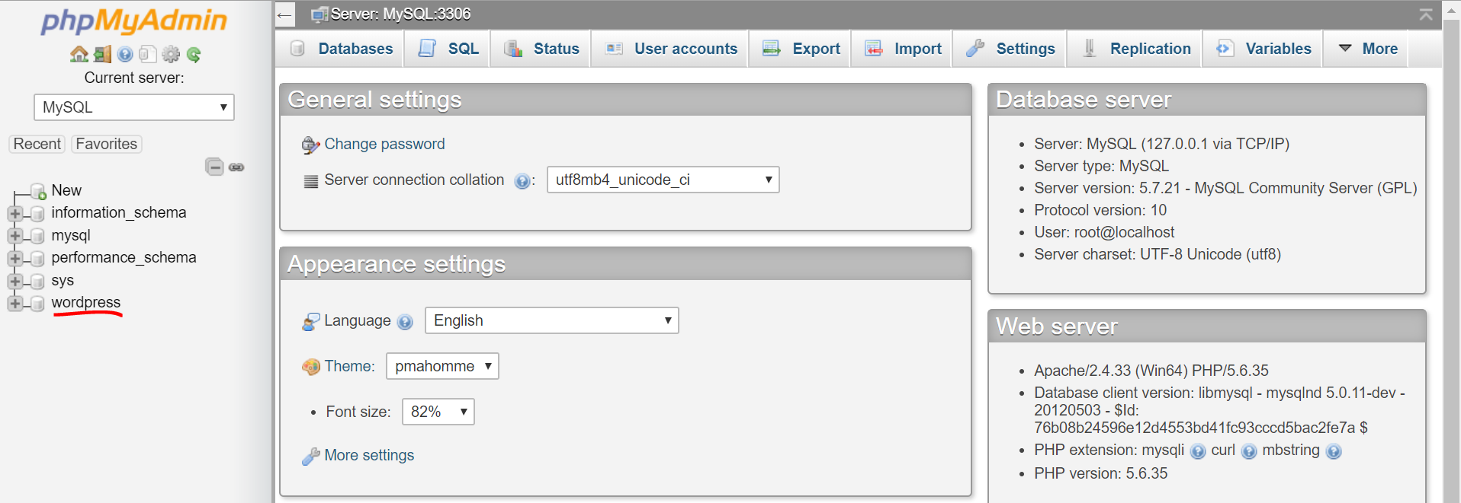

**3] Go to your browser,**

Type localhost on your URL, you will see the screen below.

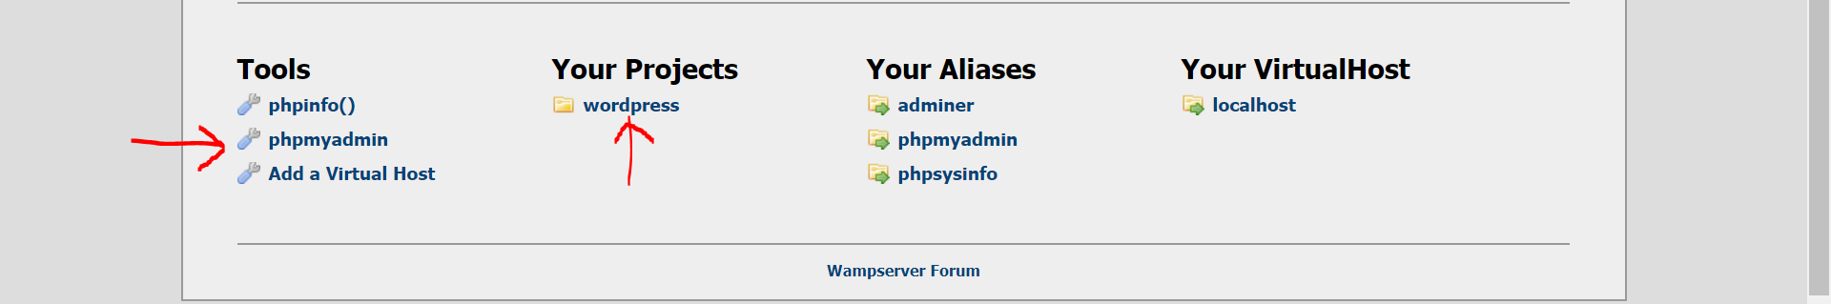

This shows that your database and your project were imported successfully.

**4] Go to the browser and type** [**http://localhost/wordpress**](http://localhost/wordpress) **in URL, you will see the screen below.**



Now you have to create an account by clicking the register option and log in to the site as a normal user.

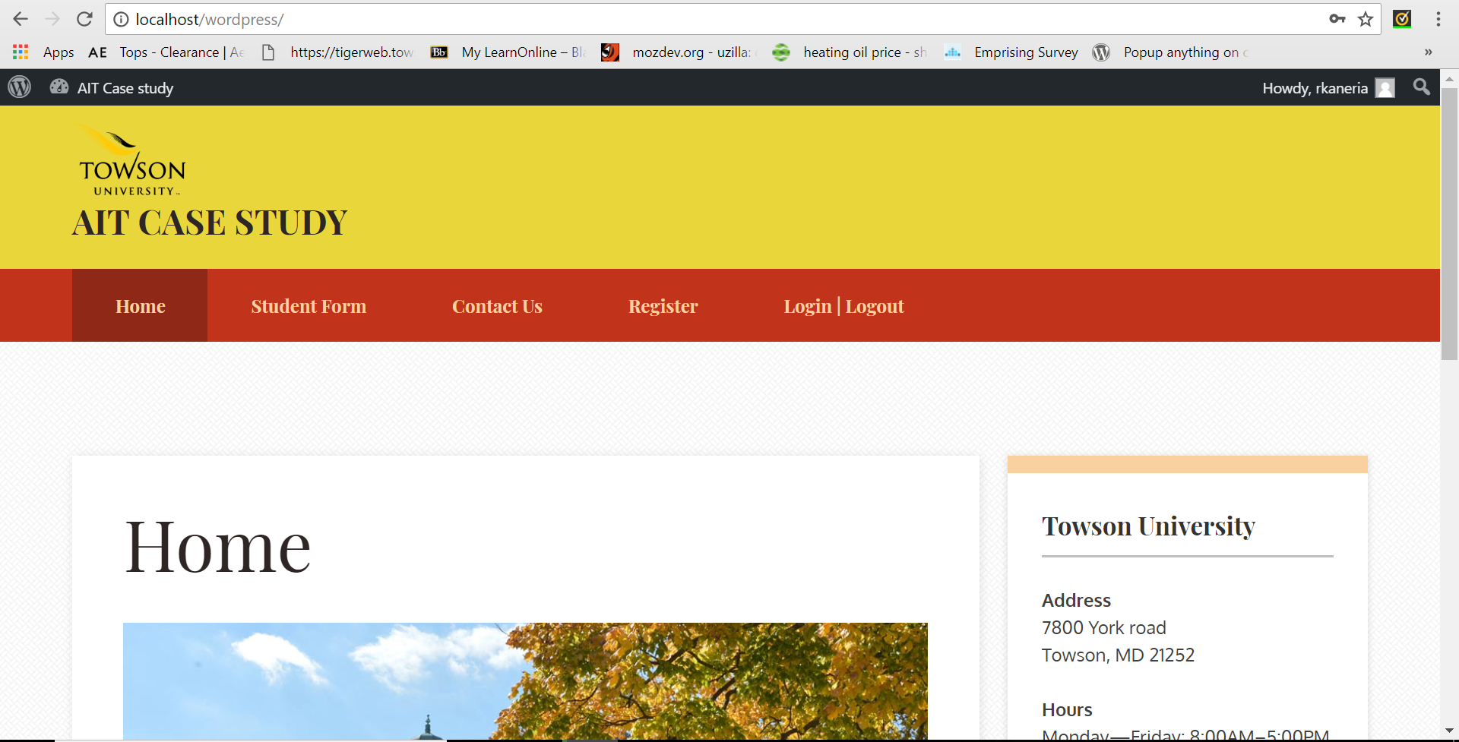

If you want to login as administrator. Go to log in page .type Username as keval and password as Kaneria@802 , you will see the screen below.



If you want to access the dashboard then click on AIT case study tab that you will see on the top of the home page.

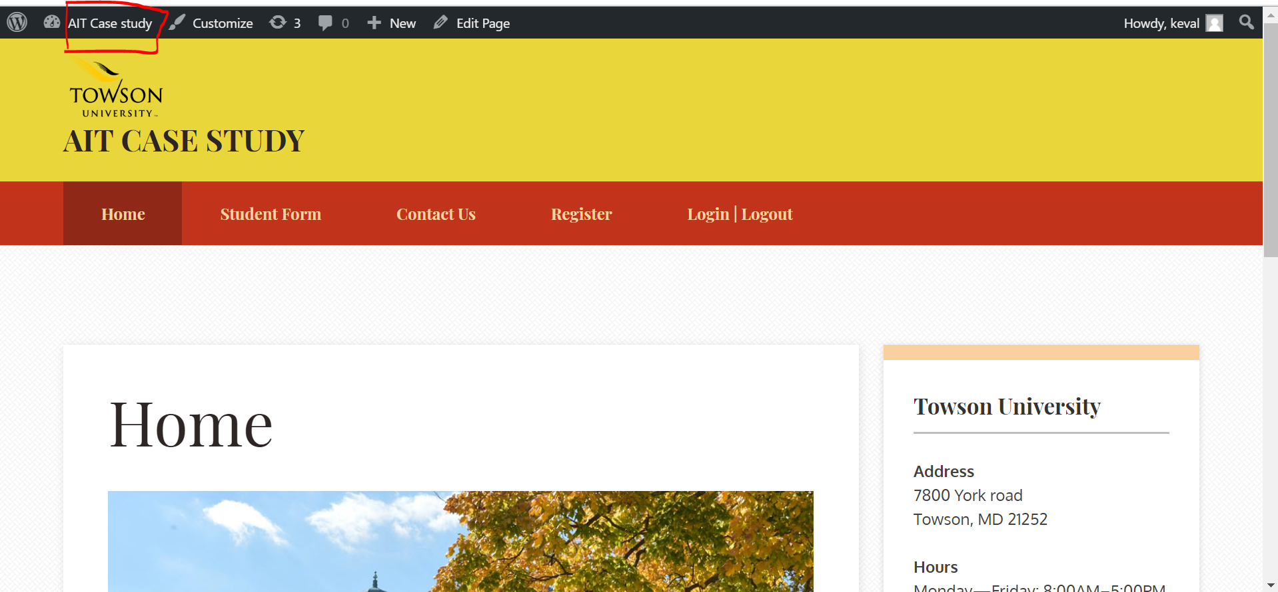

Click on AIT case study – dashboard and this will bring you to the dashboard screen and you can configure the site, as you require.

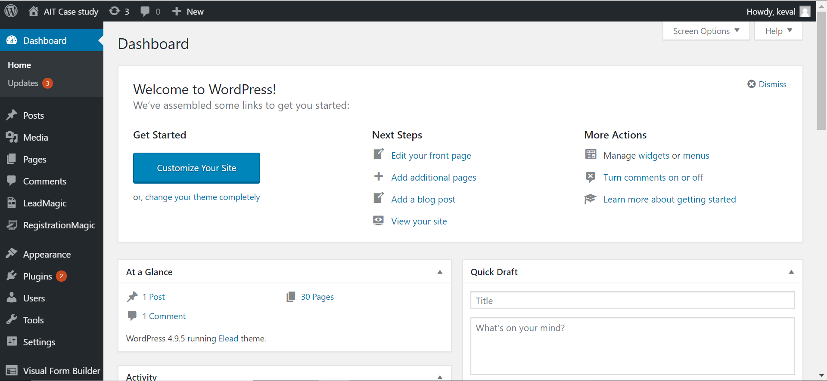

If you wish to go to the site. Click on the AIT case study option and click on visit site.

**Note: there are two plugin installed that capture student data from website.**

1. Visual form builder – capture all student form data
2. Registration magic – capture all contact us data

To view all data, you must go to **entries** section to see all data. Also there are option for export data into excel sheet.